VISUALIZING DATA (PART 1)

ONE-WAY TABLES

INDIVIDUALS AND VARIABLES
The simplest kind of information we'll work with in this course is a set of individuals with one or more properties, called variables. The individuals are the items in the data set and can be cases, things, people, etc.
In this table for heights of people, the individuals are the people, and their heights are a variable because height is a property of each individual.
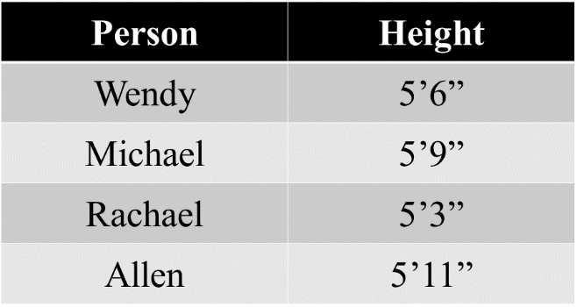

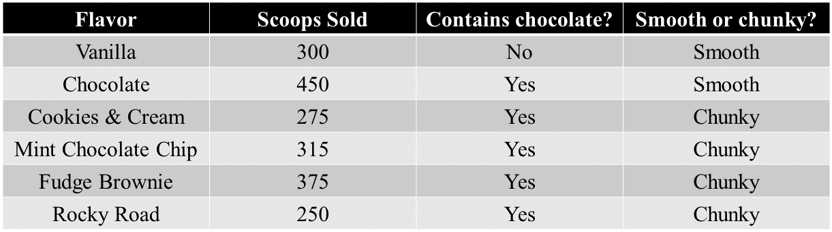
Together, individuals and variables are called data. When we organize data into a table like this one, we call it a data table. Here's an example of a data table about ice cream:
The individuals are the flavors: Vanilla, Chocolate, Cookies & Cream, etc., and the variables are their properties: Scoops sold, Contains chocolate, and Smooth or chunky.
Variables can be categorical or quantitative. In Error! Reference source not found., there's one quantitative variable: the height. In Error! Reference source not found., there's one quantitative variable (scoops), and two categorical variables (contains chocolate and smooth or chunky).

- Categorical variables are non-numerical variables. Categorical variables are also called qualitative variables. Their values aren't represented with numbers. Whether or not the ice cream contains chocolate, and whether the ice cream is smooth or chunky are categorical variables. This is because the values there are words, not numbers.

- Quantitative variables are numerical variables. Their values are numbers. The height of the people and the number of scoops of ice cream sold are quantitative variables, because the values there are numbers.
We can divide quantitative variables into discrete variables and continuous variables.
- Discrete variables are those that we can obtain by counting. Therefore, they can take on only certain numerical values. For example, the number of scoops of ice cream sold is a discrete quantitative variable, because we can't really sell 8.3 or 5.23 scoops of ice cream.

- On the other hand, continuous variables may include data as decimals, fractions, or irrational numbers. For example, the height of the people in the car is a continuous variable.

LEVELS OF MEASUREMENT
When we work with data, we need to understand the level of measurement, because not every statistical test can be used with every type of data set. There are four levels of data measurement: nominal, ordinal, interval, and ratio.
- Things like favorite food, colors, names, and "yes" or "no" responses have a nominal scale of measurement. Only categorical data can be measured with a nominal scale.

- Categorial data can also be ordinal. This type of data can be ordered. The top three national parks in Philippines is an example of ordinal data. Or, for example, when we ask a group of people about how they liked their trip, we may get responses like "awesome", "good", "satisfactory", or "terrible", or in numerical form (4,3,2,1), which follow an order from best to worst.

- Data measured using an interval scale can be ordered like ordinal data. But interval data also gives us a known interval between measurements. For example, temperature is measured using an interval scale, because we can understand the exact interval of difference between 50 and 60 degrees.

- Data measured using a ratio scale is just like interval scale data, except that ratio scale data has a starting point, or absolute zero. Whereas interval data like temperature can have negative and positive values, things like time, height, and weight are examples of ratio scale data because those measures can never be negative.
When we have a single individual and a categorical or quantitative variable assigned to it, we can construct a one-way table. These kinds of tables are called one-way because they usually represent data for one individual only.

CONSTRUCTING ONE-WAY TABLES
When we construct a table, we want to think about whether we have more individuals or more variables. In the two tables we looked at, we had the individuals listed down the left-hand side, and the variables listed across the top.
But if we have lots of variables but only a few individuals, it can be helpful to list the individuals across the top and the variables down the left side.
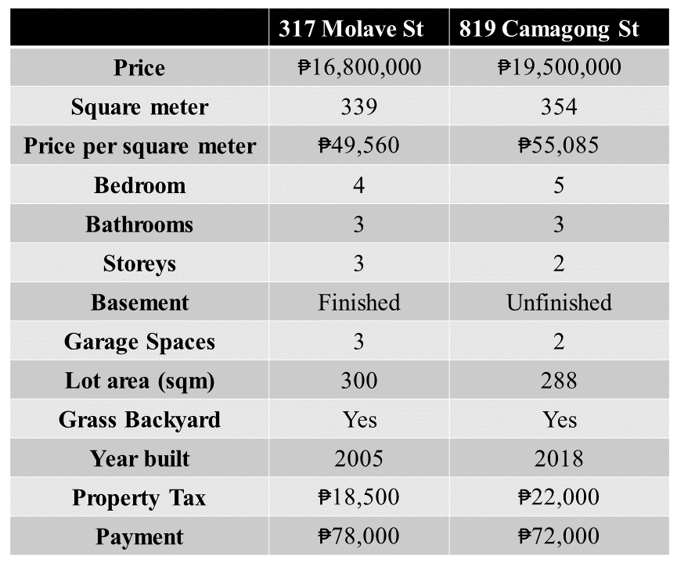
For example, if we’re comparing lots of information about two houses for sale in the same neighborhood, we might make a table like this:

The individuals are the addresses listed across the top of the table, 317 Molave St and 819 Camagong St. All the variables are listed down the left side of the table. Since there are so many more variables than individuals, listing the variables vertically makes the table fit better on paper than if we had tried to list all the variables horizontally.




Document Version: v1.0

